Available online at [www.sciencedirect.com](http://www.sciencedirect.com/)



AASRI Procedia 3 (2012) 646 – 651

2012 AASRI Conference on Modeling, Identification and Control

Short-Circuit Test Simulation System of Transformer with Shunt Capacitor under Different Frequency Source

Wang Lidia*, Wang Guangyua, Hu Weizheb

*aCollege of Information and Electrical Engineering, Shenyang Agricultural University, Shenyang 110866, P.R.China.*

*b Liaoyang Power Supply Company, Liaoyang, 111000, P.R.China.*

**Abstract**

The simulation method is useful to investigate short-circuit test of transformer and the short-circuit test of transformer is an important method for the study of transformer features. In this work, the simulation model of short-circuit test of transformer is designed. And the variable frequency power supply and shunt capacitor are considered. From the simulation results, use the shunt capacitor, the power supply can be reduced. Use the high frequency source, the capacitor can be reduced as well. This has significance in transformer test research and engineering application.

© 2012 The Authors. Published by Elsevier B.V. Open access under [CC BY-NC-ND license.](http://creativecommons.org/licenses/by-nc-nd/3.0/)

© 2012 Published by Elsevier B.V. Selection and/or peer review [under responsi](http://creativecommons.org/licenses/by-nc-nd/3.0/)bility of American Applied Science Research Institute

Selection and/or peer review under responsibility of American Applied Science Research Institute

*Keywords:* Short-Circuit test; Simulation; Variable frequency power supply; Shunt capacitor

# Introduction

Short-circuit test of transformer is an important method for the study of transformer features. The simulation method for short-circuit test of transformer is useful to investigate the working principle and characteristic of transformers. And there are many kinds of software to finish the simulation, MALAB/Simulink is one of the most popular software in this field. Some application such as the model and simulate the dynamic behavior of ac-powered electromechanical contactors[1], the integration of Matlab and Excel to conceptualize the relationship between abstract mathematical models to practical situations[2], using specially designed exercises about substation lightning protection in teaching high voltage course in Matlab[3], modeling of power systems on the transient analysis[4], the surge modelling of a transformer[5], etc. in this

* Corresponding author. Tel.: +0-086-24-88487130; fax: 0-086-24-88487122.

*E-mail address:* [wanglidi@gmail.com.](mailto:wanglidi@gmail.com)

2212-6716 © 2012 The Authors. Published by Elsevier B.V. Open access under [CC BY-NC-ND license.](http://creativecommons.org/licenses/by-nc-nd/3.0/) Selection and/or peer review under responsibility of American Applied Science Research Institute doi:10.1016/j.aasri.2012.11.103

paper, based on the simulation process of transformer test[6], consider the influence of shunt capacitor and different frequency source, the short-circuit test is applied in Matlab/Simulink.

# Short-Circuit Test of Transformer

By the short-circuit test of transformer, the copper losses of the transformer can be obtained. Short-circuit test of transformer, which shown in figure 1, is conducted by shot-circuiting the secondary terminal of transformer, then applying a reduced voltage to the primary side. When the rated current flowing in the second windings, the input voltage of the primary side is Vsc, the input of current of the primary side windings is Isc the input active power is Psc, and the input reactive power is Qsc.

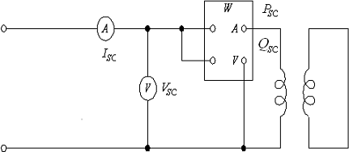

Fig. 1. Short-circuit test of transformer

According to reference[6], the short-circuit resistance Rsc and the short-circuit reactance Xsc can be calculated as follows.

*Rsc=Psc/(Isc^2) (1)*

*Xsc=Qsc/(Isc^2) (2)*

Then, the inductance Lsc is

*Lsc=Xsc/(2*pi*f) (3)*

# Resonant Capacitor And Variable Frequency Power Supply

In a circuit containing at least one inductor and one capacitor, resonance is the condition which exists when the input impedance of the circuit is purely resistive.

During the short-circuit test of transformer, in order to reduce the current of the power supply, a capacitor can be paralleled with transformer and composing an parallel resonance circuit. As we know, in the parelled resonance circuit, the capacitor can be calculated as follows.

*(4)*

In the calculation of resonant capacitor, if we increase the frequency of power supply, the capacitor will be reduced. So, we can use the high frequency power source in the short-circuit test of transformer to get the reduced parallel capacitor.

Considering the engineering realization, the third harmonic generation power supply is used in this work.

# The Simulation System Design

For the sake of evaluation, we use the transformer parameters from reference[6]. A 50KVA, 2400/240V, 50Hz transformer is used in this simulation. Its rated current of the primary side I1e=50000/2400=20.8333(A), and the secondary side current I2e=50000/240=208.333(A).

The equivalent circuit parameters of the transformer tested is R1=0.7488, RC=33,391, X1 =1.00224, XM

=5,008, R2 =0.007488, X2=0.0100224.

The ideal parameter in this simulation is

*Rsc=R1+100*R2= 0.7488+100*0.007488=1.4976 (5)*

*Xsc=X1+100*X2=1.00224+100*0.0100224=2.0045 (6)*

*Lsc=2.0045/(100*pi)=0.0064 (7)*

Based on the Matlab/Simulink platform, a simulation model is built shown as figure 2.

In this model, the short-circuit parameters are calculated by equation (1-3). Their values are

*Rsc=1.496 Xsc=2.002*

*Lsc=2.002/(100*pi)=0.006371*

A capacitor can be paralleled with the transformer and its value can be calculated based on equation (4).

*C1=L/[R2+(2fL)2]= 0.0064/(1.4976^2+(2*pi*50*0.0064)^2)= 0.0010 (F) (8)*

When the third harmonic generation power supply is used, the frequency is 150 Hz instead of 50 Hz.

Simaliar with figure 2, the simulation with 150 Hz power supply and shunt capacitor is shown in figure 3.

The ideal capacitor value when the pararel resonance occurs is:

*C2=0.0064/(1.4976^2+(2*pi*3*50*0.0064)^2)= 1.6569e-004 (F) (9)*

In the simulation model, when C2=1.6109e-004(F), the pararel resonance apppears. The ratio of the capacitor under 50 Hz source and 150 Hz source is:

*R=C1/C2=0.0010/ 1.6109e-004= 6.2077 (10)*

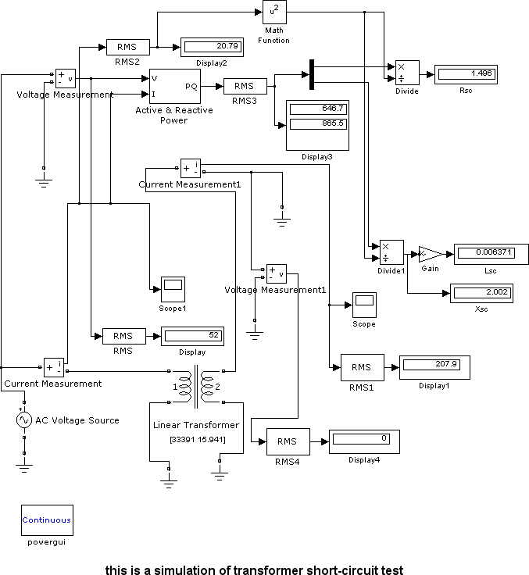

Fig. 2. Simulation model of transformer short-circuit test

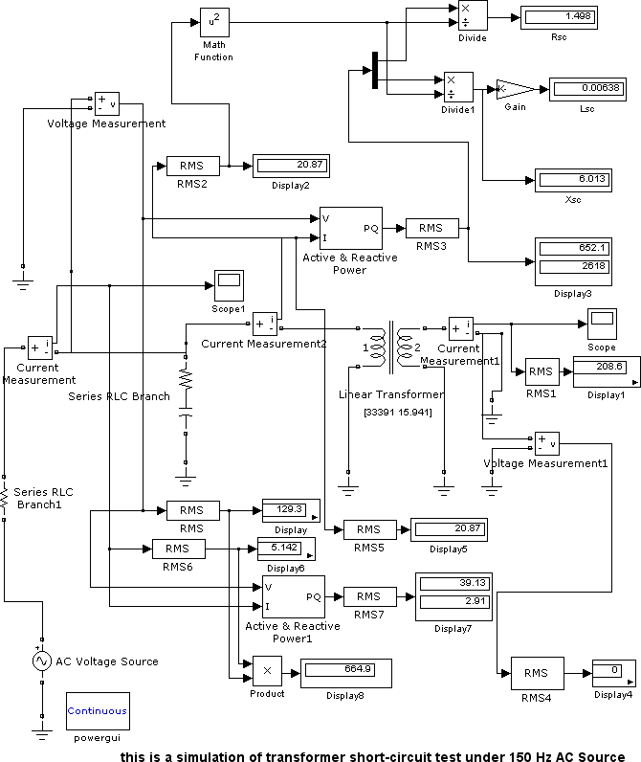

Fig. 3. Simulation model of transformer short-circuit test with variable frequency source and shunt capacitor

# Conclusions and Future Works

In this work, the simulation model of short-circuit test of transformer is designed. And the variable frequency power supply and shunt capacitor are considered. From the simulation results, use the shunt capacitor, the power supply can be reduced. Use the high frequency source, the capacitor can be reduced as well. This has significance in transformer test research and engineering application.

Under the different frequency source and shunt capacitor, the short-circuit test parameter may be variable in a small scale. The short-circuit test features should be studied in the experiments is the next work.

# Acknowledgements

This project is supported by Liaoning Province Natural Sciences Foundation (201202191) and Scientific Research Fund of Liaoning Provincial Education Department (L2010500).

# References

1. Jordi-Roger Riba Ruiz, Antonio Garcia Espinosa, Luis Romeral. A Computer Model for Teaching the Dynamic Behavior of AC Contactors. J IEEE Transactions on Education ,2010;53(2) :248-256.
2. F. L. Tan, S. C. Fok. Development of a computer-aided educational tool incorporating MATLAB for engineering measurements. J Computer Applications in Engineering Education,2009;17(2): 206-213.
3. B. Vahidi, A. A. Damaki Aliabad. A software based on MATLAB for teaching substation lightning protection design to undergraduate students with emphasize on different striking distance models. J Computer Applications in Engineering Education. 2011; 19(2): 256–267.
4. L. Sousa Martins, Dulce Costa, J. F. Martins, V. Fernão Pires. Modeling for computer simulation as a tool for the teaching of transient power systems. International Conference on Power Engineering, Energy and Electrical Drives - POWERENG, 2009.
5. K. Bhuyan, Saibal Chatterjee. Surge Modelling of Transformer Using Matlab-Simulink. Conference: IEEE India Conference - INDICON , 2009.
6. Saffet Ayasun, Chika O. Nwankpa. Transformer tests using MATLAB/Simulink and their integration into undergraduate electric machinery courses. J Computer Applications in Engineering Education. 2006; 14(2):142-150.